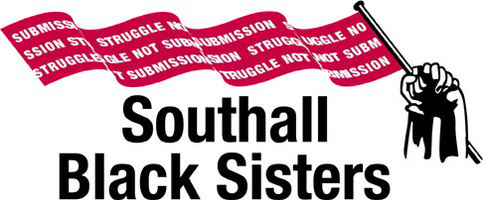

**Applicant Information**

Thank you for your interest in this post. To apply, please download the following documents from our website:

1. SBS mission statement - “Struggle not Submission”
2. Job Description and Person Specification
3. Application Form
4. Application Monitoring Form
5. Privacy Notice

Please return the application form together with the monitoring form to hr@southallblacksisters.co.uk or by post to:

HR

Southall Black Sisters

21 Avenue Road

Southall

Middlesex

UB1 3BL

Please note that applicants should pay particular attention to the Person Specification when completing the application form.

If you should have any queries, please contact Ms Frankie Favia, Finance & HR Assistant at [hr@southallblacksisters.co.uk](mailto:hr@southallblacksisters.co.uk) or 0208 571 9595.

Closing date for applications**: 5.00pm on Friday 12th March 2021**

We regret that due to the volume of applications received we are unable to acknowledge receipt. If you have not heard from us within 6 weeks of the closing date you can assume that your application has been unsuccessful.

Please note that SBS will use the data supplied in this form solely for the purpose of recruitment and selection and after six months it will be securely destroyed.